
Touchstones Project
Netcards

Justice Netcards with Text

Beloved Community HRJ
Bread HRJ
Charity HRJ
Conscience HRJ

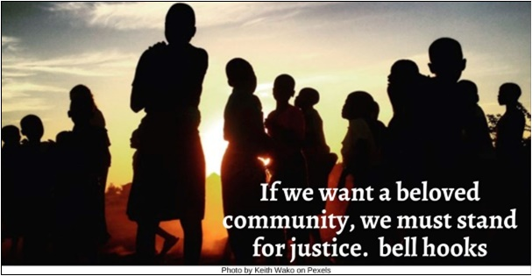

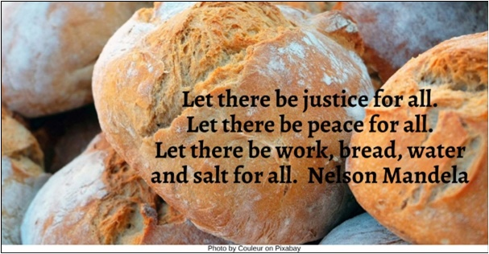

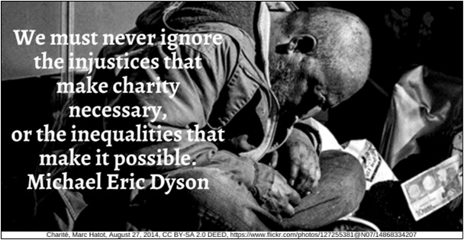

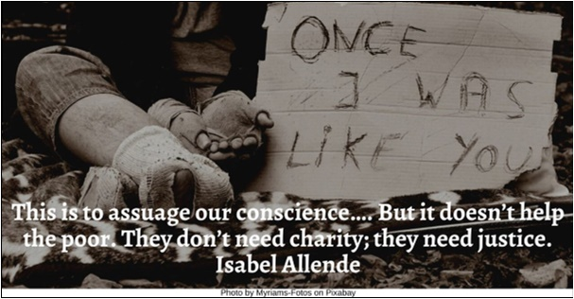

Courtroom HRJ
Delay HRJ
Democracy HRJ
Emotion HRJ

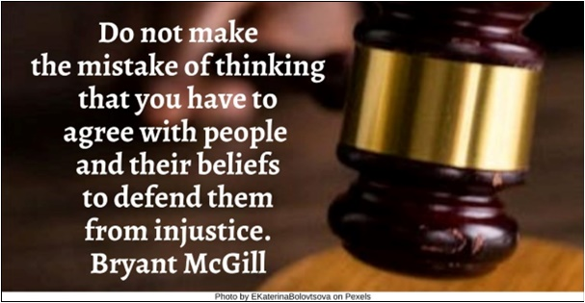

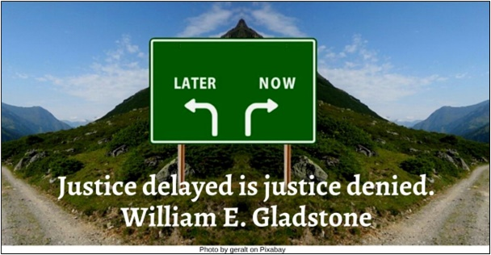

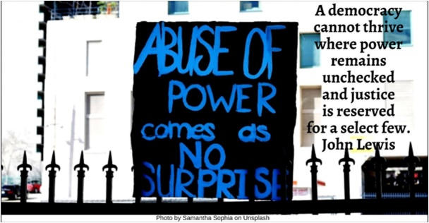

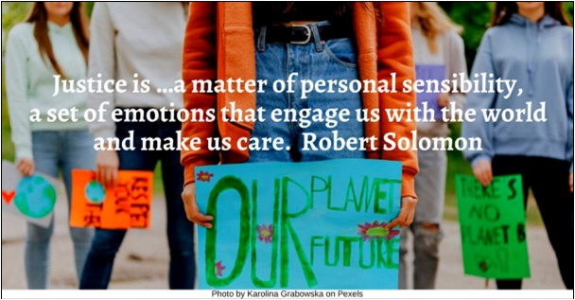

Environment HRJ
Healing HRJ
Helpless HRJ
Ignorance HRJ

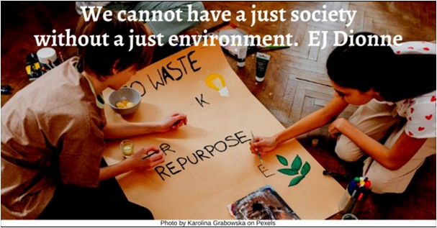

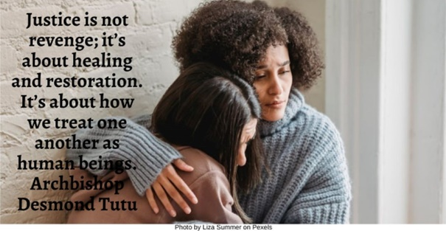

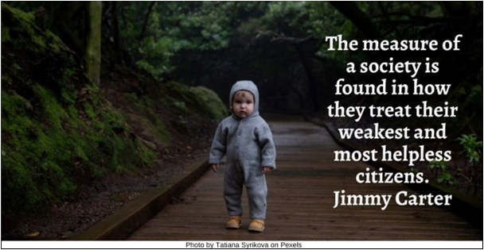

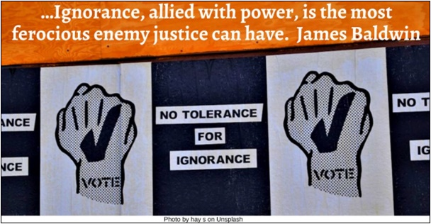

Inequality HRJ
Integrity HRJ
Justice Asleep HRJ
Law HRJ

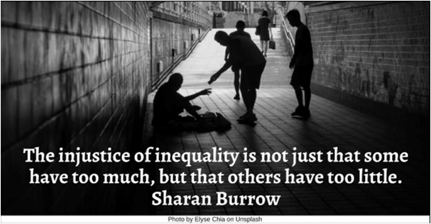

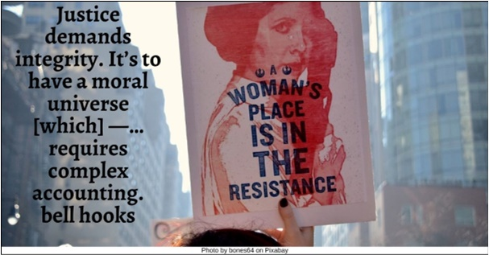

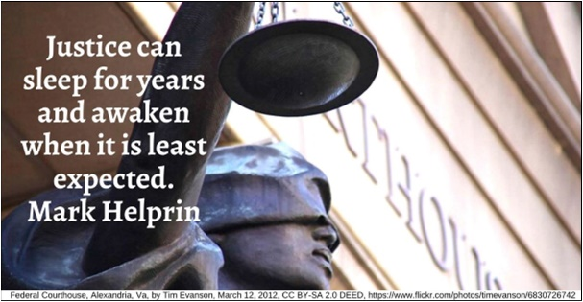

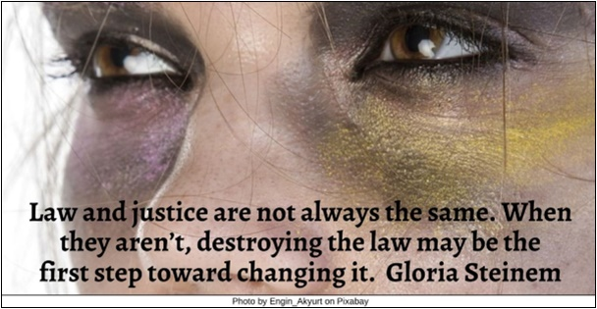

Lie HRJ
Love HRJ
Mercy HRJ
Nature HRJ

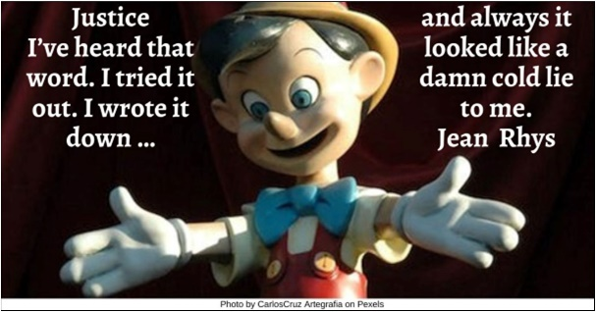

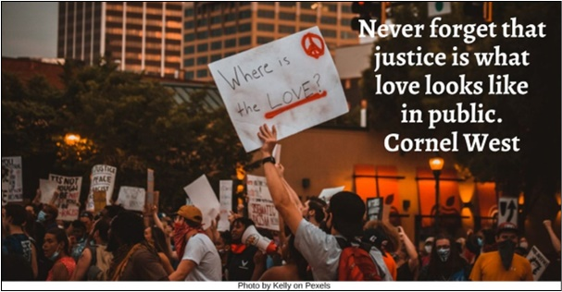

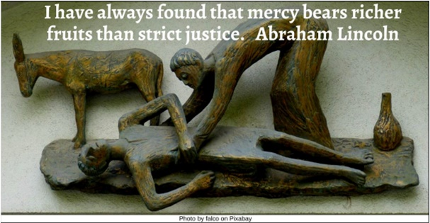

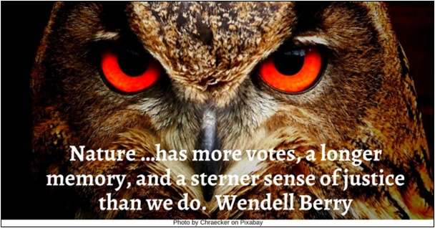

Ordinary People HRJ
Patriotism HRJ
Poverty HRJ
Power HRJ

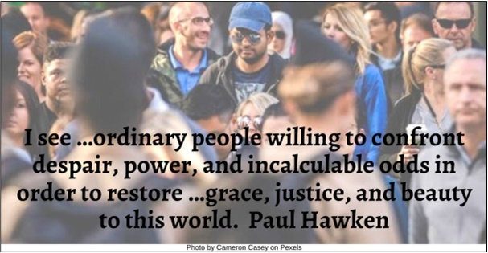

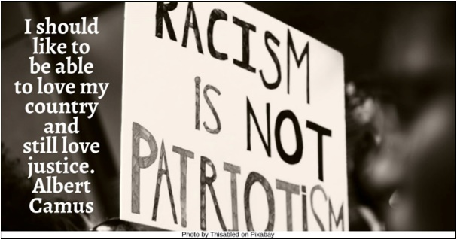

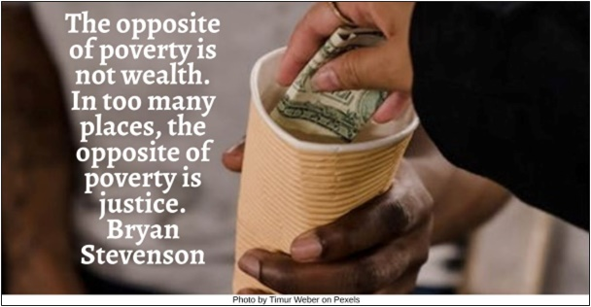

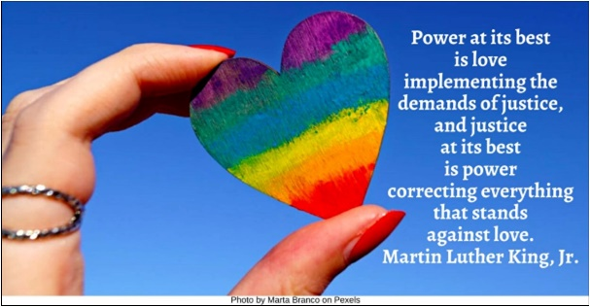

Prison HRJ
Protest HRJ
Saint HRJ
Struggle HRJ

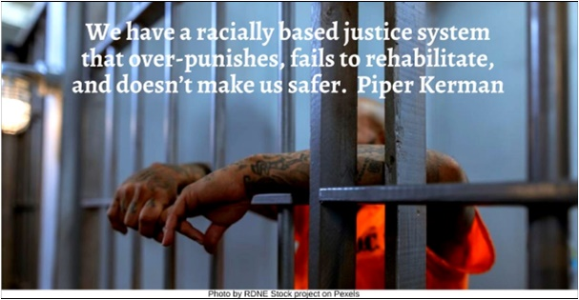

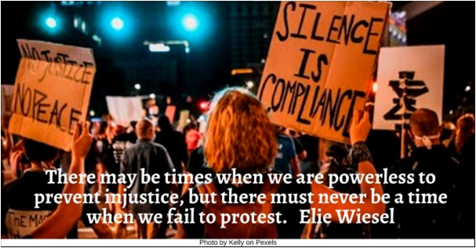

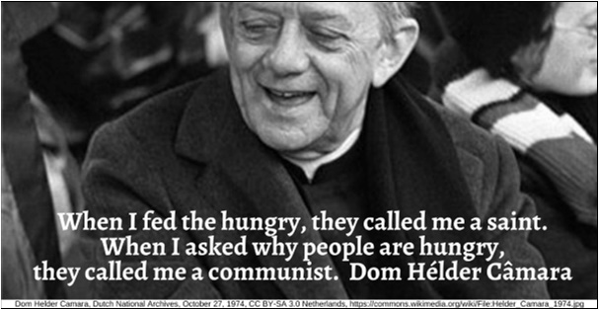

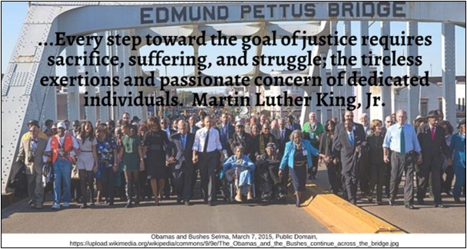

Unaffected HRJ
Wave HRJ
Yelling HRJ

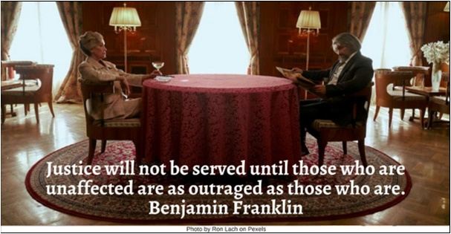

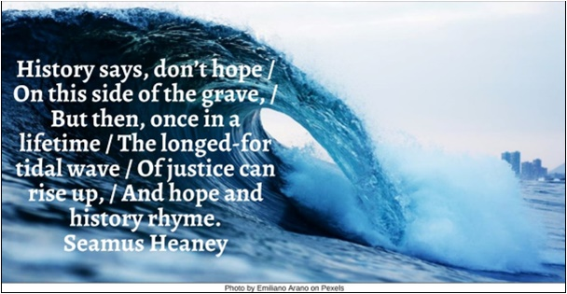

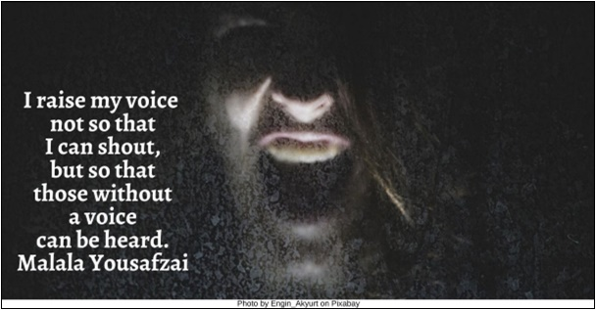

Text of Quotes
Beloved Community HRJ
If we want a beloved community, we must stand for justice. bell hooks

Bread HRJ
Let there be justice for all. Let there be peace for all. Let there be work, bread, water and salt for all. Nelson Mandela

Charity HRJ
We must never ignore the injustices that make charity necessary, or the inequalities that make it possible. Michael Eric Dyson

Conscience HRJ
This is to assuage our conscience…. But it doesn’t help the poor. They don’t need charity; they need justice.” Isabel Allende

Courtroom HRJ
Do not make the mistake of thinking that you have to agree with people and their beliefs to defend them from injustice. Bryant McGill

Delay HRJ
Justice delayed is justice denied. William E. Gladstone

Democracy HRJ
A democracy cannot thrive where power remains unchecked and justice is reserved for a select few. John Lewis

Emotion HRJ
Justice is …a matter of personal sensibility, a set of emotions that engage us with the world and make us care. Robert Solomon

Environment HRJ
We cannot have a just society without a just environment. EJ Dionne

Healing HRJ
Justice is not revenge; it’s about healing and restoration. It’s about how we treat one another as human beings. Archbishop Desmond Tutu

Helpless HRJ
The measure of a society is found in how they treat their weakest and most helpless citizens. Jimmy Carter

Ignorance HRJ
…Ignorance, allied with power, is the most ferocious enemy justice can have. James Baldwin

Inequality HRJ
The injustice of inequality is not just that some have too much, but that others have too little. Sharan Burrow

Integrity HRJ
Justice demands integrity. It’s to have a moral universe [which] —…requires complex accounting. bell hooks

Justice Asleep HRJ
Justice can sleep for years and awaken when it is least expected. Mark Helprin

Law HRJ
Law and justice are not always the same. When they aren’t, destroying the law may be the first step toward changing it. Gloria Steinem

Lie HRJ
Justice. I’ve heard that word. I tried it out. I wrote it down …and always it looked like a damn cold lie to me. Jean Rhys

Love HRJ
Never forget that justice is what love looks like in public. Cornel West

Mercy HRJ
I have always found that mercy bears richer fruits than strict justice. Abraham Lincoln

Nature HRJ
Nature …has more votes, a longer memory, and a sterner sense of justice than we do. Wendell Berry

Ordinary People HRJ
I see …ordinary people willing to confront despair, power, and incalculable odds in order to restore …grace, justice, and beauty to this world. Paul Hawken

Patriotism HRJ
I should like to be able to love my country and still love justice. Albert Camus

Poverty HRJ
The opposite of poverty is not wealth. In too many places, the opposite of poverty is justice. Bryan Stevenson

Power HRJ
Power at its best is love implementing the demands of justice, and justice at its best is power correcting everything that stands against love. Martin Luther King, Jr.

Prison HRJ
We have a racially based justice system that over-punishes, fails to rehabilitate, and doesn’t make us safer. Piper Kerman

Protest HRJ
There may be times when we are powerless to prevent injustice, but there must never be a time when we fail to protest. Elie Wiesel

Saint HRJ
When I fed the hungry, they called me a saint. When I asked why people are hungry, they called me a communist. Dom Hélder Câmara

Struggle HRJ
...Every step toward the goal of justice requires sacrifice, suffering, and struggle; the tireless exertions and passionate concern of dedicated individuals. Martin Luther King, Jr.

Unaffected HRJ
Justice will not be served until those who are unaffected are as outraged as those who are. Benjamin Franklin
Photo by Ron Lach on Pexels

Wave HRJ
History says, don’t hope / On this side of the grave, / But then, once in a lifetime / The longed-for tidal wave / Of justice can rise up, / And hope and history rhyme. Seamus Heaney

Yelling HRJ
I raise my voice not so that I can shout, but so that those without a voice can be heard. Malala Yousafzai

